DAY 4 LAB EXPERIMENTS

Name: M.Satyanarayana
Reg.no: 192472029
Dept: B.Tech CSE (AI)

Scenario: You are working on a project that involves analyzing customer reviews for a product.
You have a dataset containing customer reviews, and your task is to develop a Python program that
calculates the frequency distribution of words in the reviews.
Question: Develop a Python program to calculate the frequency distribution of words in the
customer reviews dataset?
Solution:
import pandas as pd
from collections import Counter
import re

data = {
"reviews": [
"This product is very good and useful",
"The quality of the product is excellent",
"Very bad experience with this product",
"The product quality is good and price is reasonable",
"Excellent product and very good performance"
]
}
df = pd.DataFrame(data)
all_text = " ".join(df["reviews"]).lower()
words = re.findall(r'\b\w+\b', all_text)
word_freq = Counter(words)
print(word_freq)
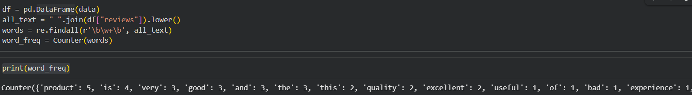

Scenario: You are a data analyst working for a marketing research company. Your team has
collected a large dataset containing customer feedback from various social media platforms. The
dataset consists of thousands of text entries, and your task is to develop a Python program to
analyze the frequency distribution of words in this dataset. Your program should be able to perform
the following tasks:
- Load the dataset from a CSV file (data.csv) containing a single column named "feedback"
- with each row representing a customer comment.
- Preprocess the text data by removing punctuation, converting all text to lowercase, and
- eliminating any stop words (common words like "the," "and," "is," etc. that don't carry
- significant meaning).
- Calculate the frequency distribution of words in the preprocessed dataset.
- Display the top N most frequent words and their corresponding frequencies, where N is
- provided as user input.
- Plot a bar graph to visualize the top N most frequent words and their frequencies.
Question: Create a Python program that fulfills these requirements and helps your team gain
insights from the customer feedback data.
Solution:
import pandas as pd
import re
import matplotlib.pyplot as plt
from collections import Counter

df = pd.read_csv("data.csv")

text = " ".join(df["feedback"].astype(str))
text = text.lower()
text = re.sub(r'[^\w\s]', '', text)

stop_words = {
"the","and","is","in","to","of","for","on","with","this","that","it",
"as","are","was","were","be","been","has","have","had","but","by",
"from","at","or","an","a","we","you","they","their","our","your"
}

words = [word for word in text.split() if word not in stop_words]

word_freq = Counter(words)

N = int(input("Enter the value of N: "))

top_words = word_freq.most_common(N)

print("\nTop", N, "Most Frequent Words:")
for word, freq in top_words:
print(f"{word} : {freq}")

labels, values = zip(*top_words)

plt.bar(labels, values)
plt.xlabel("Words")
plt.ylabel("Frequency")
plt.title(f"Top {N} Most Frequent Words in Customer Feedback")
plt.xticks(rotation=45)
plt.tight_layout()
plt.show()
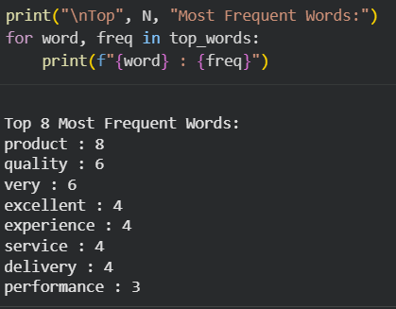

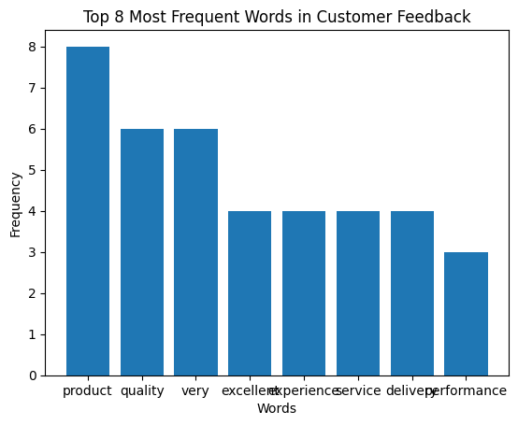

Scenario: Suppose a hospital tested the age and body fat data for 18 randomly selected adults with the following result.
Question:
- Calculate the mean, median and standard deviation of age and %fat using Pandas.
- Draw the boxplots for age and %fat.
- Draw a scatter plot and a q-q plot based on these two variables
Solution:
import pandas as pd
import matplotlib.pyplot as plt
import scipy.stats as stats

data = {
"age": [23, 23, 27, 27, 39, 41, 47, 49, 50, 52, 54, 54, 56, 57, 58, 58, 60, 61],
"fat": [9.5, 26.5, 7.8, 17.8, 31.4, 25.9, 27.4, 27.2, 31.2,
34.6, 42.5, 28.8, 33.4, 30.2, 34.1, 32.9, 41.2, 35.7]
}

df = pd.DataFrame(data)

print("Mean:\n", df.mean())
print("\nMedian:\n", df.median())
print("\nStandard Deviation:\n", df.std())

plt.boxplot(df["age"])
plt.title("Boxplot of Age")
plt.ylabel("Age")
plt.show()

plt.boxplot(df["fat"])
plt.title("Boxplot of Body Fat Percentage")
plt.ylabel("% Body Fat")
plt.show()

plt.scatter(df["age"], df["fat"])
plt.xlabel("Age")
plt.ylabel("Body Fat Percentage")
plt.title("Scatter Plot of Age vs Body Fat")
plt.show()

stats.probplot(df["age"], dist="norm", plot=plt)
plt.title("Q-Q Plot of Age")
plt.show()

stats.probplot(df["fat"], dist="norm", plot=plt)
plt.title("Q-Q Plot of Body Fat Percentage")
plt.show()
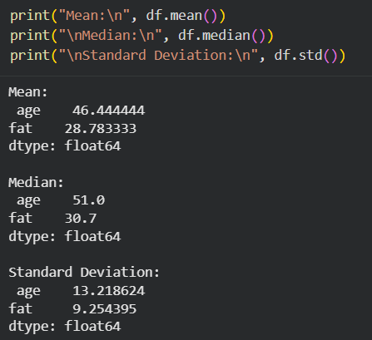

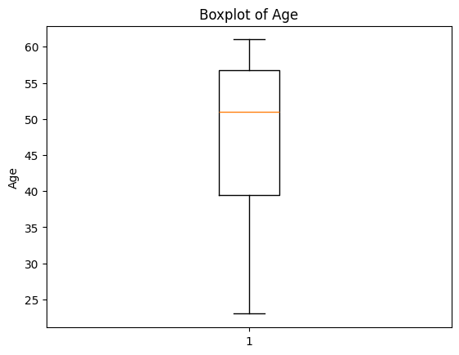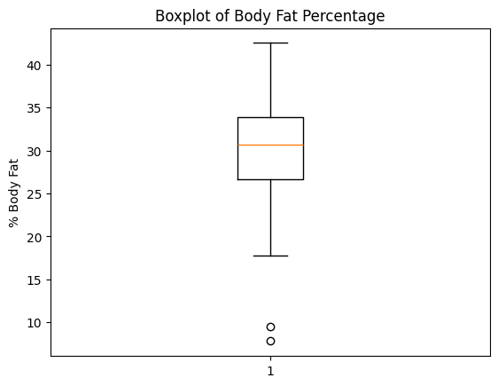

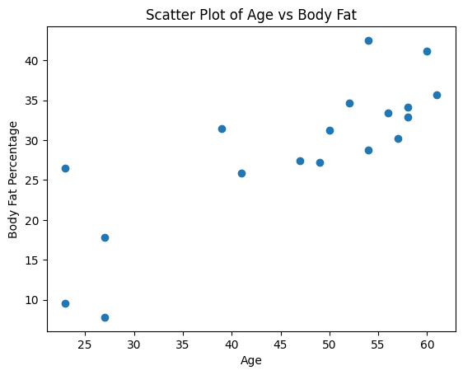

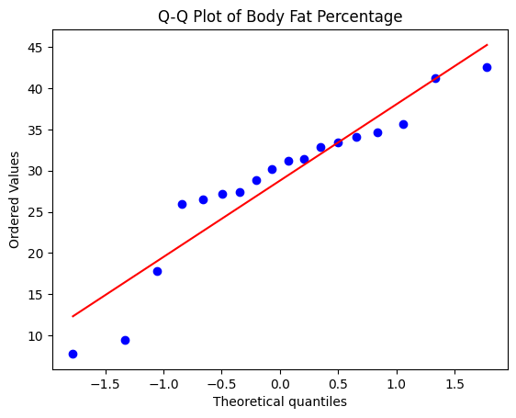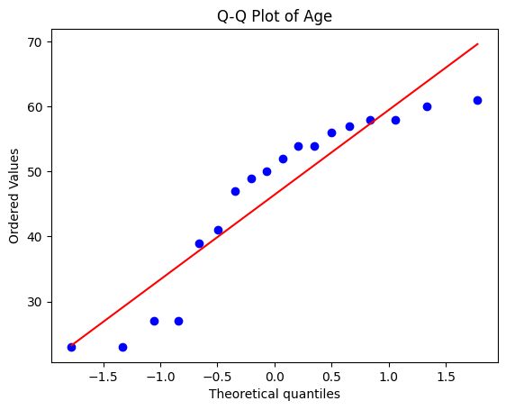

Scenario: You are a medical researcher investigating the effectiveness of a new drug in reducing blood pressure. You conduct a clinical trial with a sample of 50 patients who were randomly assigned to receive either the new drug or a placebo. After measuring their blood pressure levels at the end of the trial, you obtain the data for both groups. Now, you want to determine the confidence intervals for the mean reduction in blood pressure for both the drug and placebo groups.
Question: "What is the 95% confidence interval for the mean reduction in blood pressure for patients who received the new drug? Also, what is the 95% confidence interval for the mean reduction in blood pressure for patients who received the placebo?
Solution:
import numpy as np
import scipy.stats as stats
drug_reduction = np.array([
12, 15, 14, 10, 13, 16, 18, 14, 15, 17,11, 13, 16, 14, 15, 17, 12, 14, 16, 18, 13, 15, 14, 16, 17 ])
placebo_reduction = np.array([ 2, 3, 1, 4, 2, 3, 2, 1, 3, 4, 2, 1, 3, 2, 4, 1, 2, 3, 1, 2, 3, 2, 1, 3, 2])

def confidence_interval(data, confidence=0.95):
mean = np.mean(data)
std = np.std(data, ddof=1)
n = len(data)
t_value = stats.t.ppf((1 + confidence) / 2, n - 1)
margin = t_value * (std / np.sqrt(n))
return mean - margin, mean + margin

drug_ci = confidence_interval(drug_reduction)
placebo_ci = confidence_interval(placebo_reduction)

print("95% Confidence Interval for Drug Group:", drug_ci)
print("95% Confidence Interval for Placebo Group:", placebo_ci)

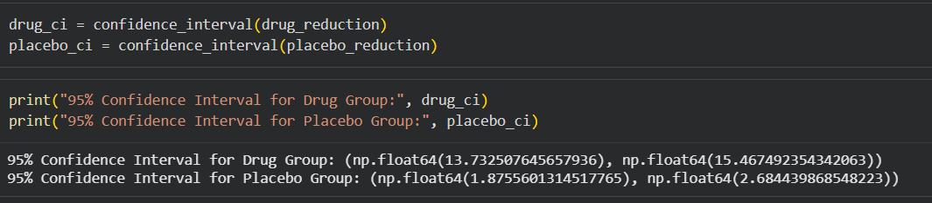

Scenario: You are a data scientist working for an e-commerce company. The marketing team has conducted an A/B test to evaluate the effectiveness of two different website designs (A and B) in terms of conversion rate. They randomly divided the website visitors into two groups, with one group experiencing design A and the other experiencing design B. After a week of data collection, you now have the conversion rate data for both groups. You want to determine whether there is a statistically significant difference in the mean conversion rates between the two website designs.
Question: "Based on the data collected from the A/B test, is there a statistically significant difference in the mean conversion rates between website design A and website design B?"
Solution:
import numpy as np
from scipy.stats import ttest_ind

design_A = np.array([3.2, 3.5, 3.1, 3.4, 3.6, 3.3, 3.2, 3.5, 3.4, 3.3])
design_B = np.array([3.8, 4.0, 3.9, 4.1, 3.7, 4.0, 3.9, 4.2, 3.8, 4.1])

t_stat, p_value = ttest_ind(design_A, design_B)

print("T-statistic:", t_stat)
print("P-value:", p_value)
